THE SALUKI OR GAZELLE HOUND CLUB

JUDGING QUESTIONNAIRE

*In composing the judging lists for any year, the Committee is governed by the criteria published in the Yearbook, a copy of which is attached. Please refer to these if you are not sure what answers to give and please ignore any questions which you think are not relevant to your status.*

Name ……………………………………………………………………

Address……………………………………………………………………………………………………………………..

………………………………………………………………………………………………………………………

*The Saluki or Gazelle Hound Club take the privacy of your data very seriously and will securely store your name and address as a part of your application to join our Judges List. We will only use these details to contact you, and not use them for any other purpose without your specific consent.*

*You can decide not to provide your Telephone and/or Email contact details. By providing either of them you will be consenting to them appearing in the Judges List published on the Club website (www.salukiclub.co.uk), and in the Club Yearbook that is only for the use of Club members.*

Telephone………………………… e-mail……………………………………………

Give details of your association with Salukis (how long owned, lived with, exhibited etc.)

……………………………………………………………………………………………

……………………………………………………………………………………………

Number of years experience judging (a) Salukis ………. (b) other breeds………..

Up to 3 dogs bred or owned by you when each one obtained a Stud Book number

Name

Breed

Stud Book number

Stewarding appointments: no. of Shows …….. , no. of years ……..

Have you stewarded Saluki classes? …….. : no. of Shows ……..

Have you attended a Seminar run in accordance with KC guidelines on

1. KC Regulations and judging procedure? …… did you pass the examination? ..….
2. Conformation and movement? .…..
3. Breed assessment? .….. what standard did you reach? …… (d) Breed information? ……

Give below the names and dates of Shows at which you judged Salukis in the UK and any future appointments confirmed in writing. *(Continue on another sheet if necessary.)*

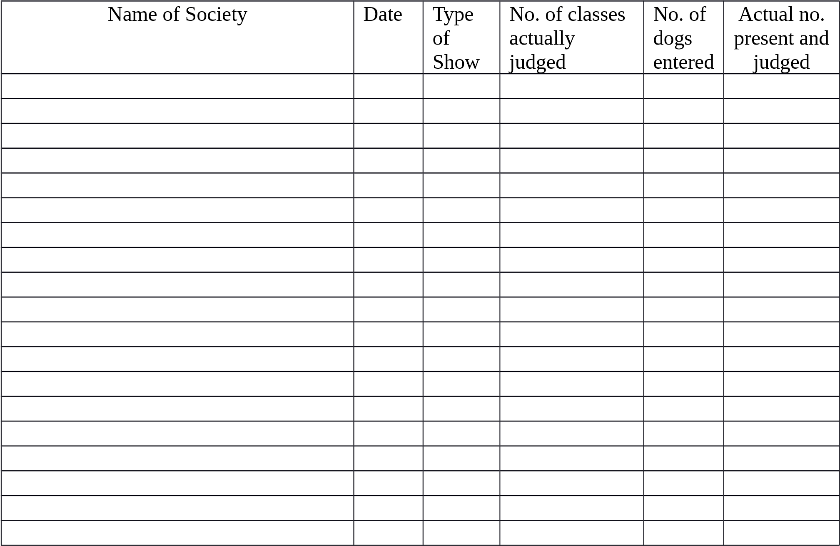

Give names of any other sighthound breeds for which you are passed to award CC’s and the date of your first appointment

…………………………………………………………………………………………………………………………………………

…………………………………………………………………………………………………………………………………………

Signed ……………………………………………. Date ………………………………………….

*Please return the completed form to the Secretary of the Saluki or Gazelle Hound Club –* Dr Michelle Ulyatt, Meadow View, Crooks Court Lane, West Hougham, Kent, CT15 7BN T: 07907 056903 E: secretary@salukiclub.co.uk